International conference - Expressivity, Bodies & Language in the 21st century
November, 20-21, University of Montpellier - Paul Valéry

Co-organized by Sandrine Sorlin (University of Montpellier - Paul Valéry/IUF) & Julie Neveux (Celiso, Sorbonne University)

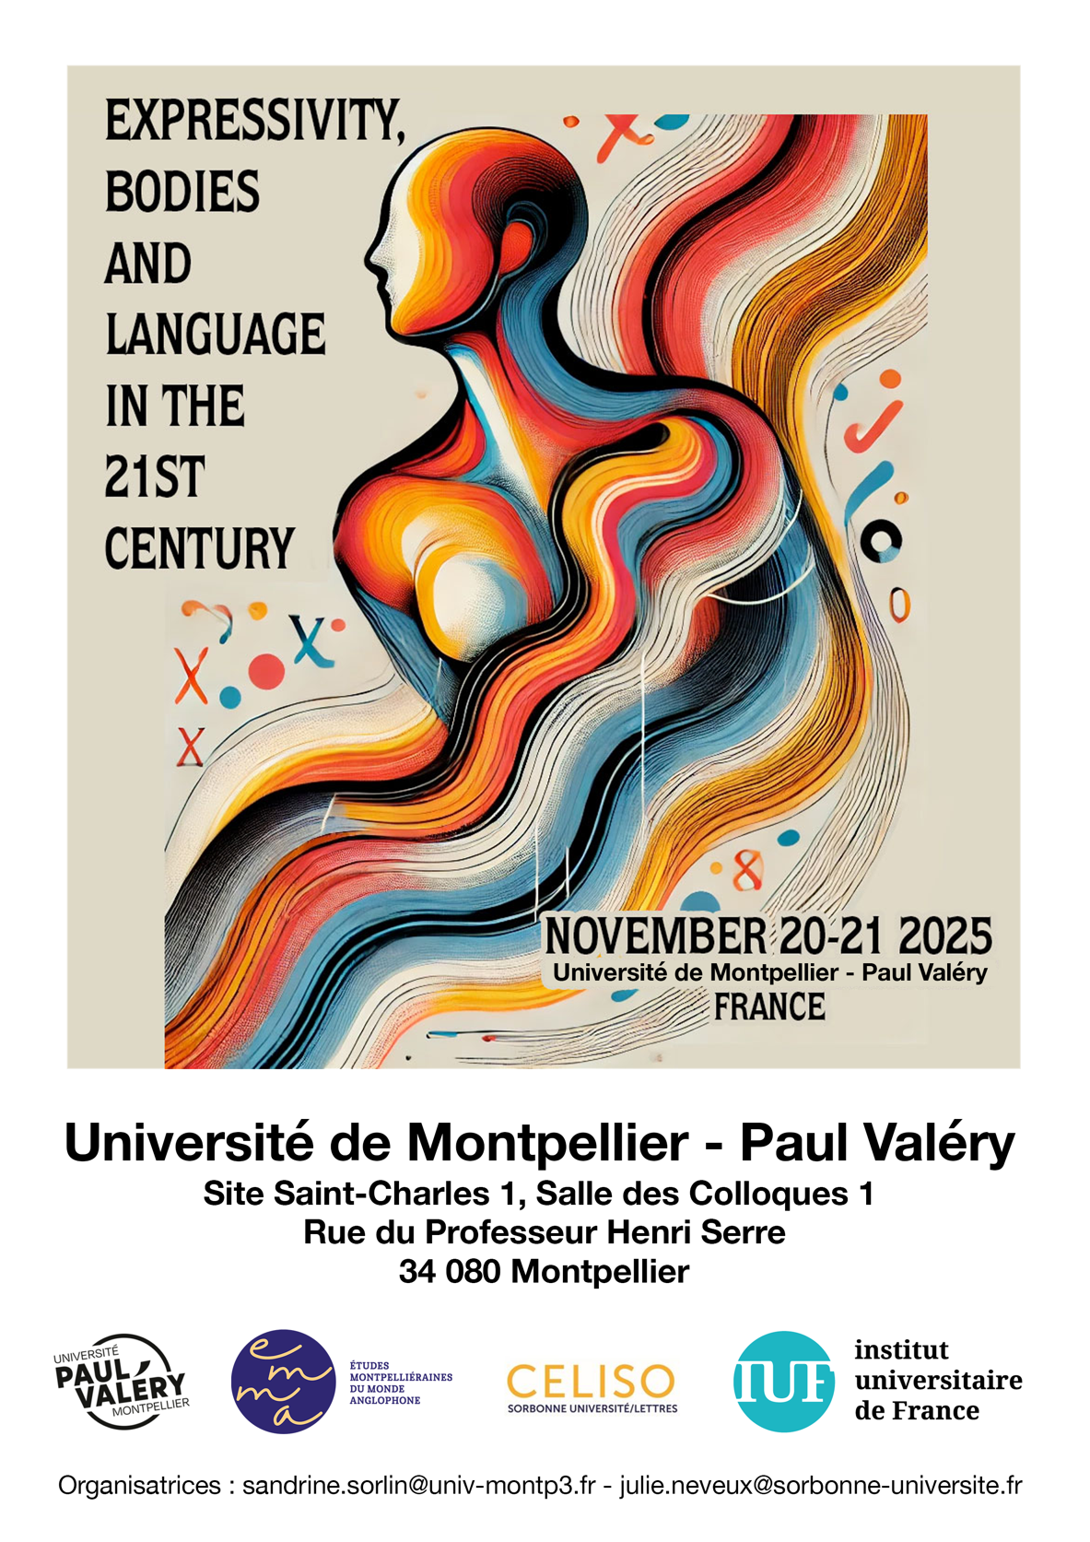

November 20th 2025
9h15 Opening words (Sandrine Sorlin & Julie Neveux)
Chair: Ann Coady (University of Montpellier - Paul Valéry)
9h30 Ad Foolen (Radboud University, Nijmegen, The Netherlands) : “Loaded language in woke discourse”
10h Lieven Vandelanotte (University of Namur & KU Leuven, Belgium) & Barbara Dancygier (University of British Columbia, Canada) : “Performing emotions in discourse across image and text”
10h30-11h Coffee Break
Chair: Sandrine Sorlin (University of Montpellier - Paul Valéry)
11h Ismaël Pozner, Gil van Mulders & Louis de Saussure (University of Neuchâtel, Switzerland) : “Fleshing out meaning: Understanding with experiences”
11h30-12h30 KEYNOTE speaker: Laura Alba-Juez (Universidad Nacional de Educación a Distancia, Madrid, Spain) “I’ll never call him dad again” : Emotional inferences and embodiment in the Giselle Pélicot sexual assault case in France.
12h30-14h00 LUNCH
Chair: Louis de Saussure (University of Neuchâtel, Switzerland)
14h Pauline Beaupoil-Hourdel (Sorbonne University, INSPE de Paris, France), Christelle Dodane (Sorbonne Nouvelle University, France) & Aliyah Morgenstern (Sorbonne Nouvelle University, France) : “Embodied negation: a developmental perspective on a French child’s coordination of action, gesture, and speech”
14h30 Aurore Vincenti (Independent researcher, France) : “‘No’ a short word for a big job: the somatic and political implications of setting boundaries”
15h00 Virginie Iché (University of Montpellier Paul Valéry, France) : “The Pleasure of Offense in 21st-Century Stand-up Comedy Specials: A (Multimodal) Pragmatic Analysis of Louis CK and Dave Chappelle”
15h30-16h Coffee break
Chair: Aliyah Morgenstern (Sorbonne Nouvelle University, France)
16h00 Anne Holm (Linnaeus University, Sweden) : “Mediating Authenticity: Multilingualism and Metaphoric Gestures as Communicative Resources in Spoken Word Poetry”
16h30 Amandine Vattaire (Jean Moulin Lyon 3 University, France) : “Characters of Sonic Bodies: The Enactive Potential of Expressivity in Audiobooks”
17h00 Julien Longhi (CY Cergy Paris University, France) : “Exploring Perlocutionary Effects and Expressive Communication in Coach-Athlete Interactions: A Linguistic Study of Table Tennis Coaching”
19h30 Dinner in Town

November 21th 2025
Chair: Virginie Iché (University of Montpellier - Paul Valéry)
9h KEYNOTE speaker Christopher HART (Lancaster University, UK) : “The Embodied Performance of Right-Wing Populism”
10h Giuseppe Balirano (University of Naples L’Orientale, Italy) : “Translating the Body: Italian Criminal Discourse in English Subtitles”
10h30 Steffen Wöll (Leipzig University, Germany) : “Speaking, Seeing, Touching, Dying: Transforming the Body through (Visual) Language in David Cronenberg’s Videodrome”
11h-11h30 Coffee break
Chair: Florence Floquet (University of Montpellier - Paul Valéry)
11h30 Amalia Cotoi (Babeș-Bolyai University, Cluj-Napoca, Roumania): "Embodied Language and Maternal Relationality: The Mother–Daughter Dynamic in Contemporary Literature"
12h Gi Taek Ryoo (Chungbuk National University, Korea) : “Feeling the Climate Crisis: The Affective Dimension of Experimental Language”
12h30-14h00 LUNCH
Chair: Julie Neveux (Sorbonne University, France)
14h00 KEYNOTE speaker Ezequiel A. Di Paolo (Ikerbasque, the Basque Foundation for Science, Spain) : “The historicity of linguistic bodies”
Chair: Lynn Blin (University of Montpellier - Paul Valéry)
15h00 Aliyah Morgenstern (Sorbonne Nouvelle University, France) Pauline Beaupoil-Hourdel (Sorbonne University & INSPE, France) & al : “Embodied Language and Multimodal Coordination in French Family Dinners”
15h30 Solenn Delannoye (University Sorbonne Nouvelle, France) : "The expression and embodiment of surprise in adult-child interaction: A medium for socialization"
16h-16h30 Coffee break
Chair: Julie Neveux and Sandrine Sorlin
16h30 Cédric Sarré (Sorbonne University, INSPE, France) : “‘Working on my (poker) face!’ Multimodal manifestations of self-conscious emotions in technology-mediated talk-in-interaction”
17h00 Jean-Rémi Lapaire (Bordeaux Montaigne University, France) : “Engaging the ‘phenomenal body’ in language learning”

